文藻外語大學校旗暨校錦旗申請表
Application form for Wenzao flag and banner
申請物品 Items
□校旗 數量：______ 面 (金額：350元/面)  Wenzao Flag Quantity: (NT$350/each)  尺寸：87公分*138公分 Dimensions:87x138cm  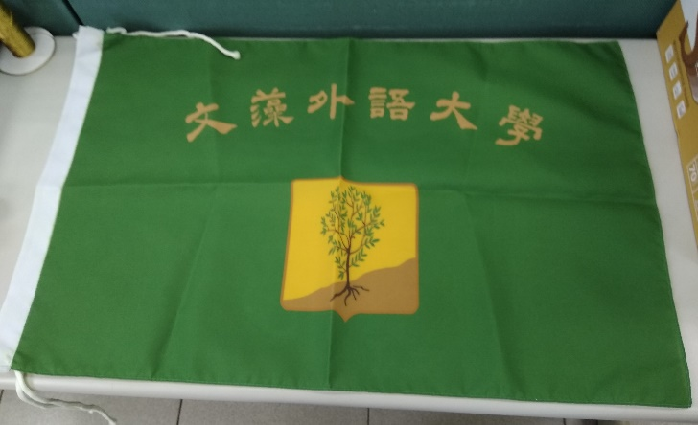 |  | □校錦旗 數量：______ 面(金額：140元/面)  Wenzao Banner Quantity: (NT$140/each)  尺寸：46公分*28公分 Dimensions:46x28cm  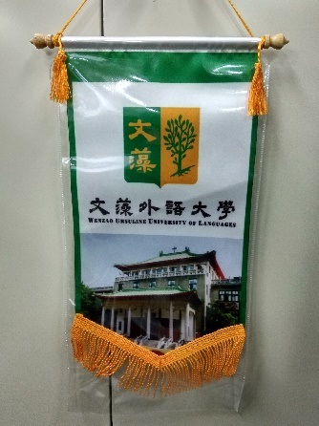
申請需求 Requirements
□借用 Borrowing (例：服務隊營期借用off-campus service work)
□領用Collecting (例：致贈姊妹校、貴賓等 as a gift to partner schools or guests)
用途說明 Reason for Application
□自行付費 Paid by a user □申請免付費 Apply for free use
說明(Note)：

申請單位 Application Unit
申請人 Applicant | 二級主管 Unit Head |  | 一級主管 Unit Head
管理暨決行單位  Management and decision | 事務組  Purchasing & Supply Section |  | 總務處  Office of General Affairs
收費蓋章
Stamped upon payment
領用/借用日期  Borrowing date | 領用/借用人簽章 Signature( borrower) |  | 備註 Remark
歸還日期 Return date | 收取人簽章 Signature (receiver) |  | 備註 Remark
總務處製表
2019.02.20

